Project Planning Phase
Project Planning Template(ProductBacklog,SprintPlanning, Stories, Story points)

Date Team ID
Project Name Maximum Marks
3 December 2025

SHOPEZ : E-commerce Application 5 Marks

Product Backlog, Sprint Schedule, and Estimation (4 Marks)

Product Backlog & Sprint Schedule
Sprin | Functional | User | User Story / Task | Stor | Priori | Team
t | Requirement | Story |  | y | ty | Mem
 | (Epic) | Number |  | Poin |  | bers
 |  |  |  | ts

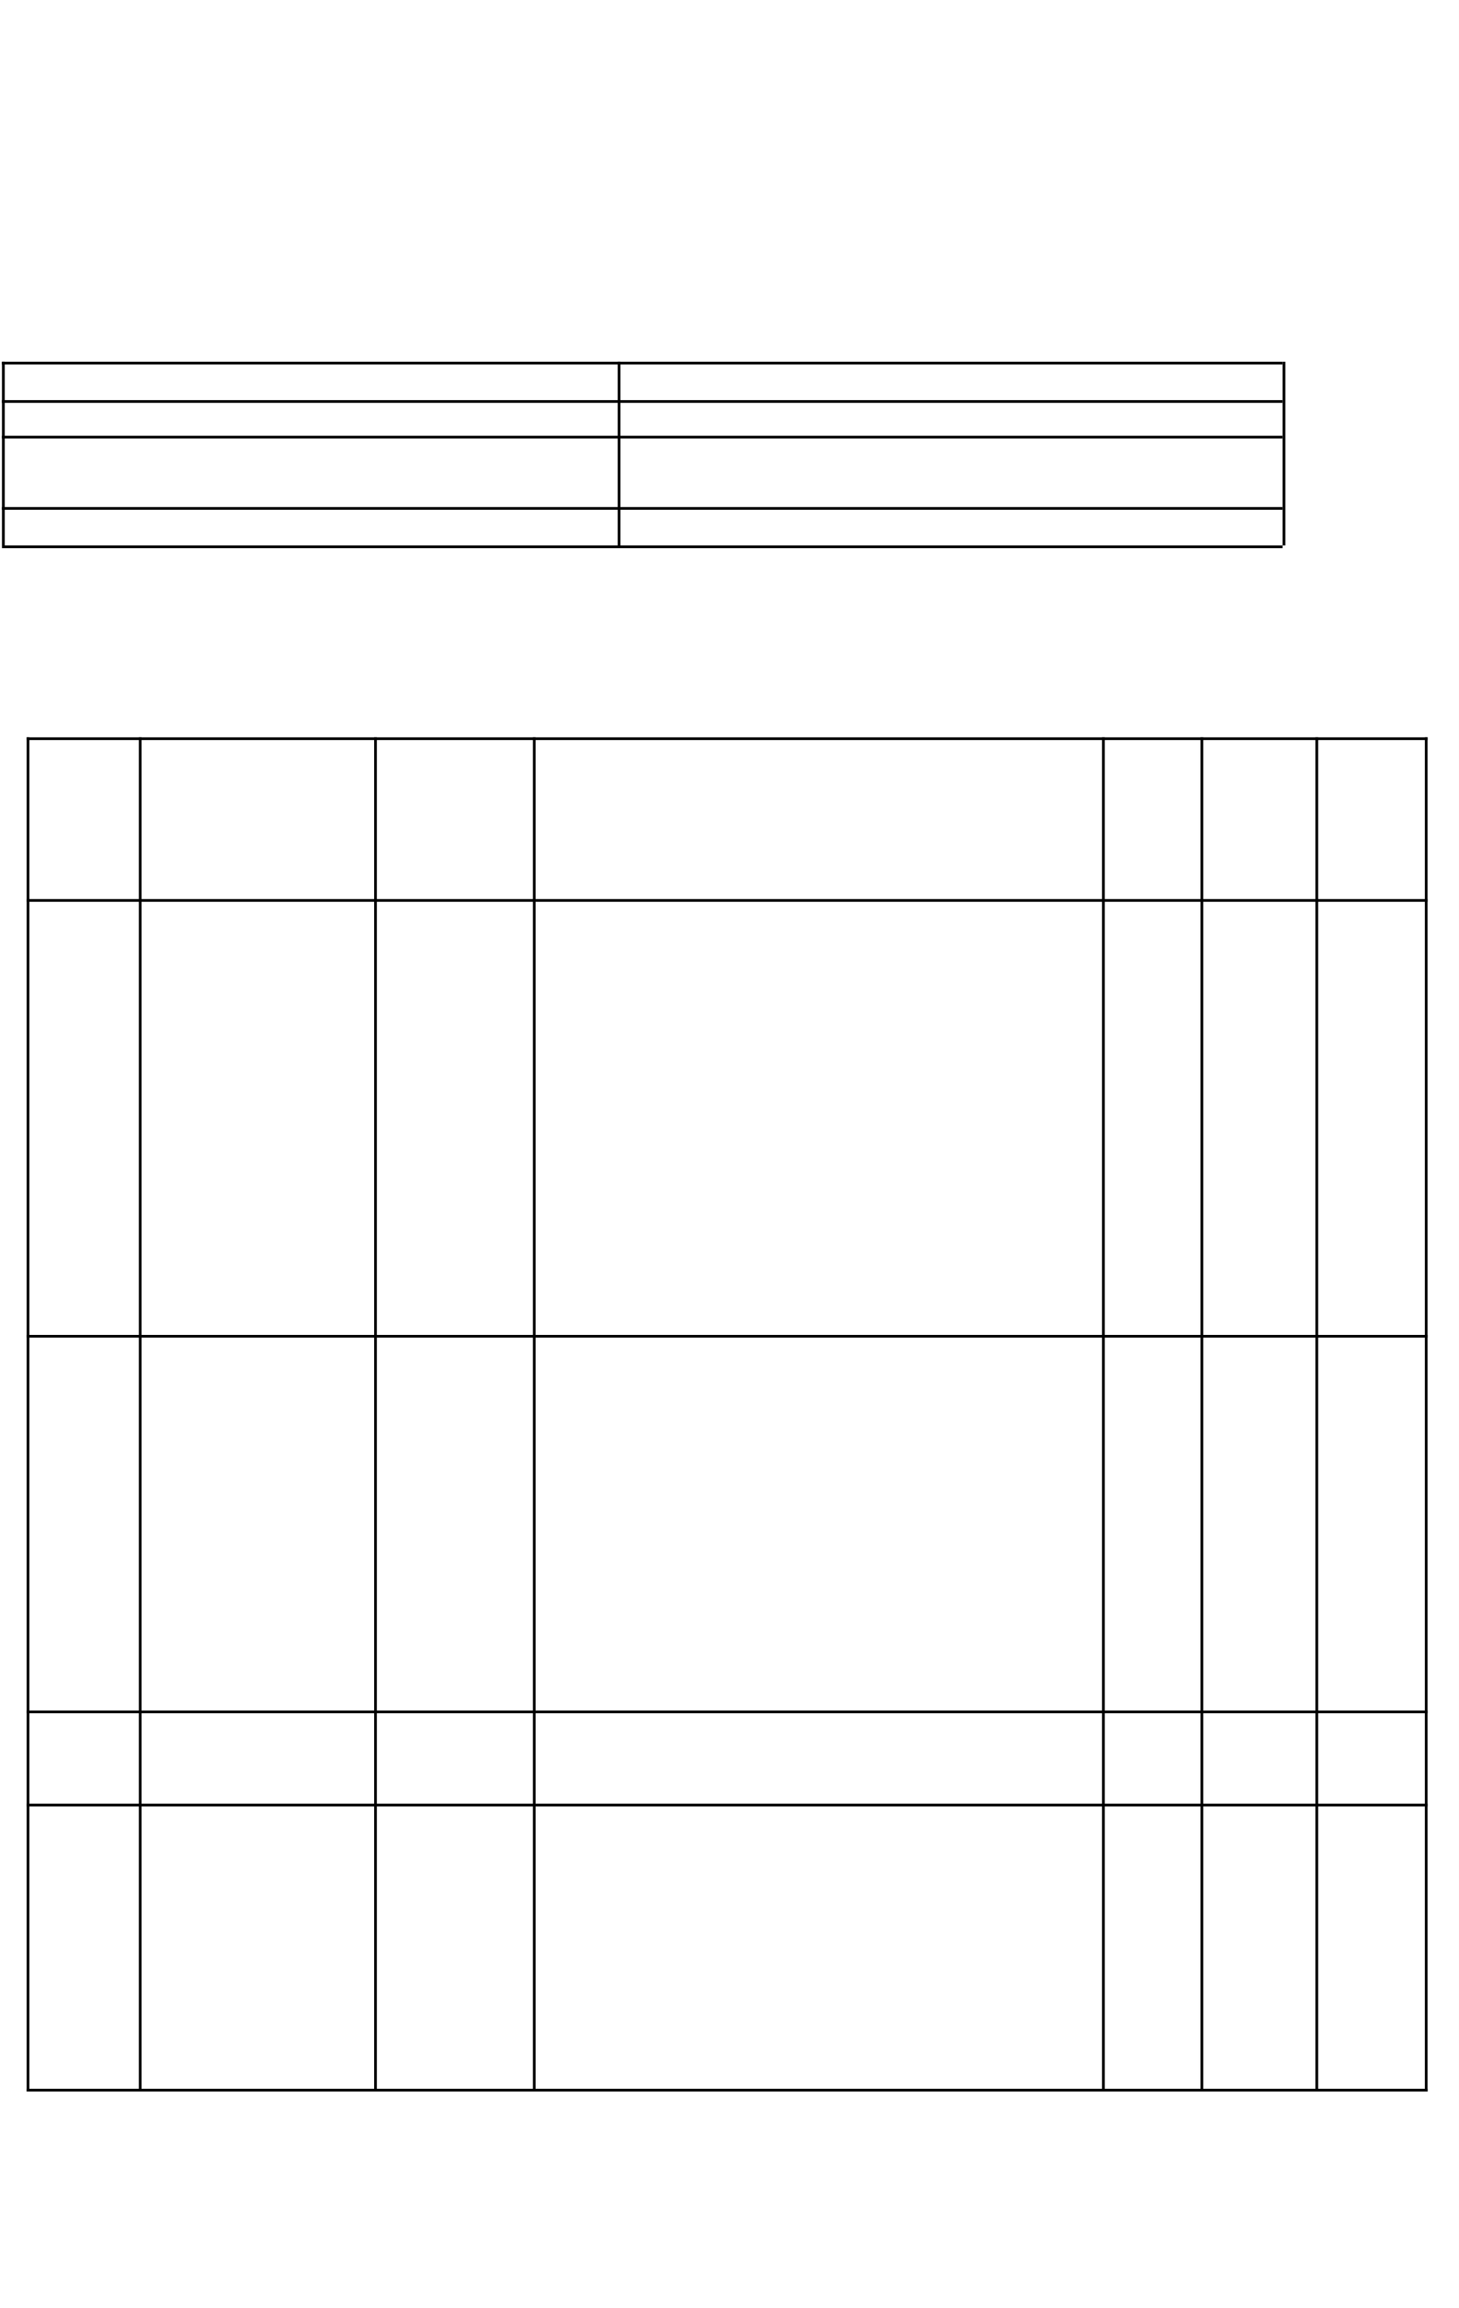
Sprin t-1

Sprin t-2

Authenticati on

Product Browsing

USN-1

USN-2

USN-3
As a customer/admin/seller, I can 3
register and log in securely.

As a user, I can reset my 2
password securely.
As a customer, I can browse, search, 3
and filter products.

High

Mediu m

High

Cart & Checkout

USN-4
As a customer, I can add items to my cart and place an order.
3 High

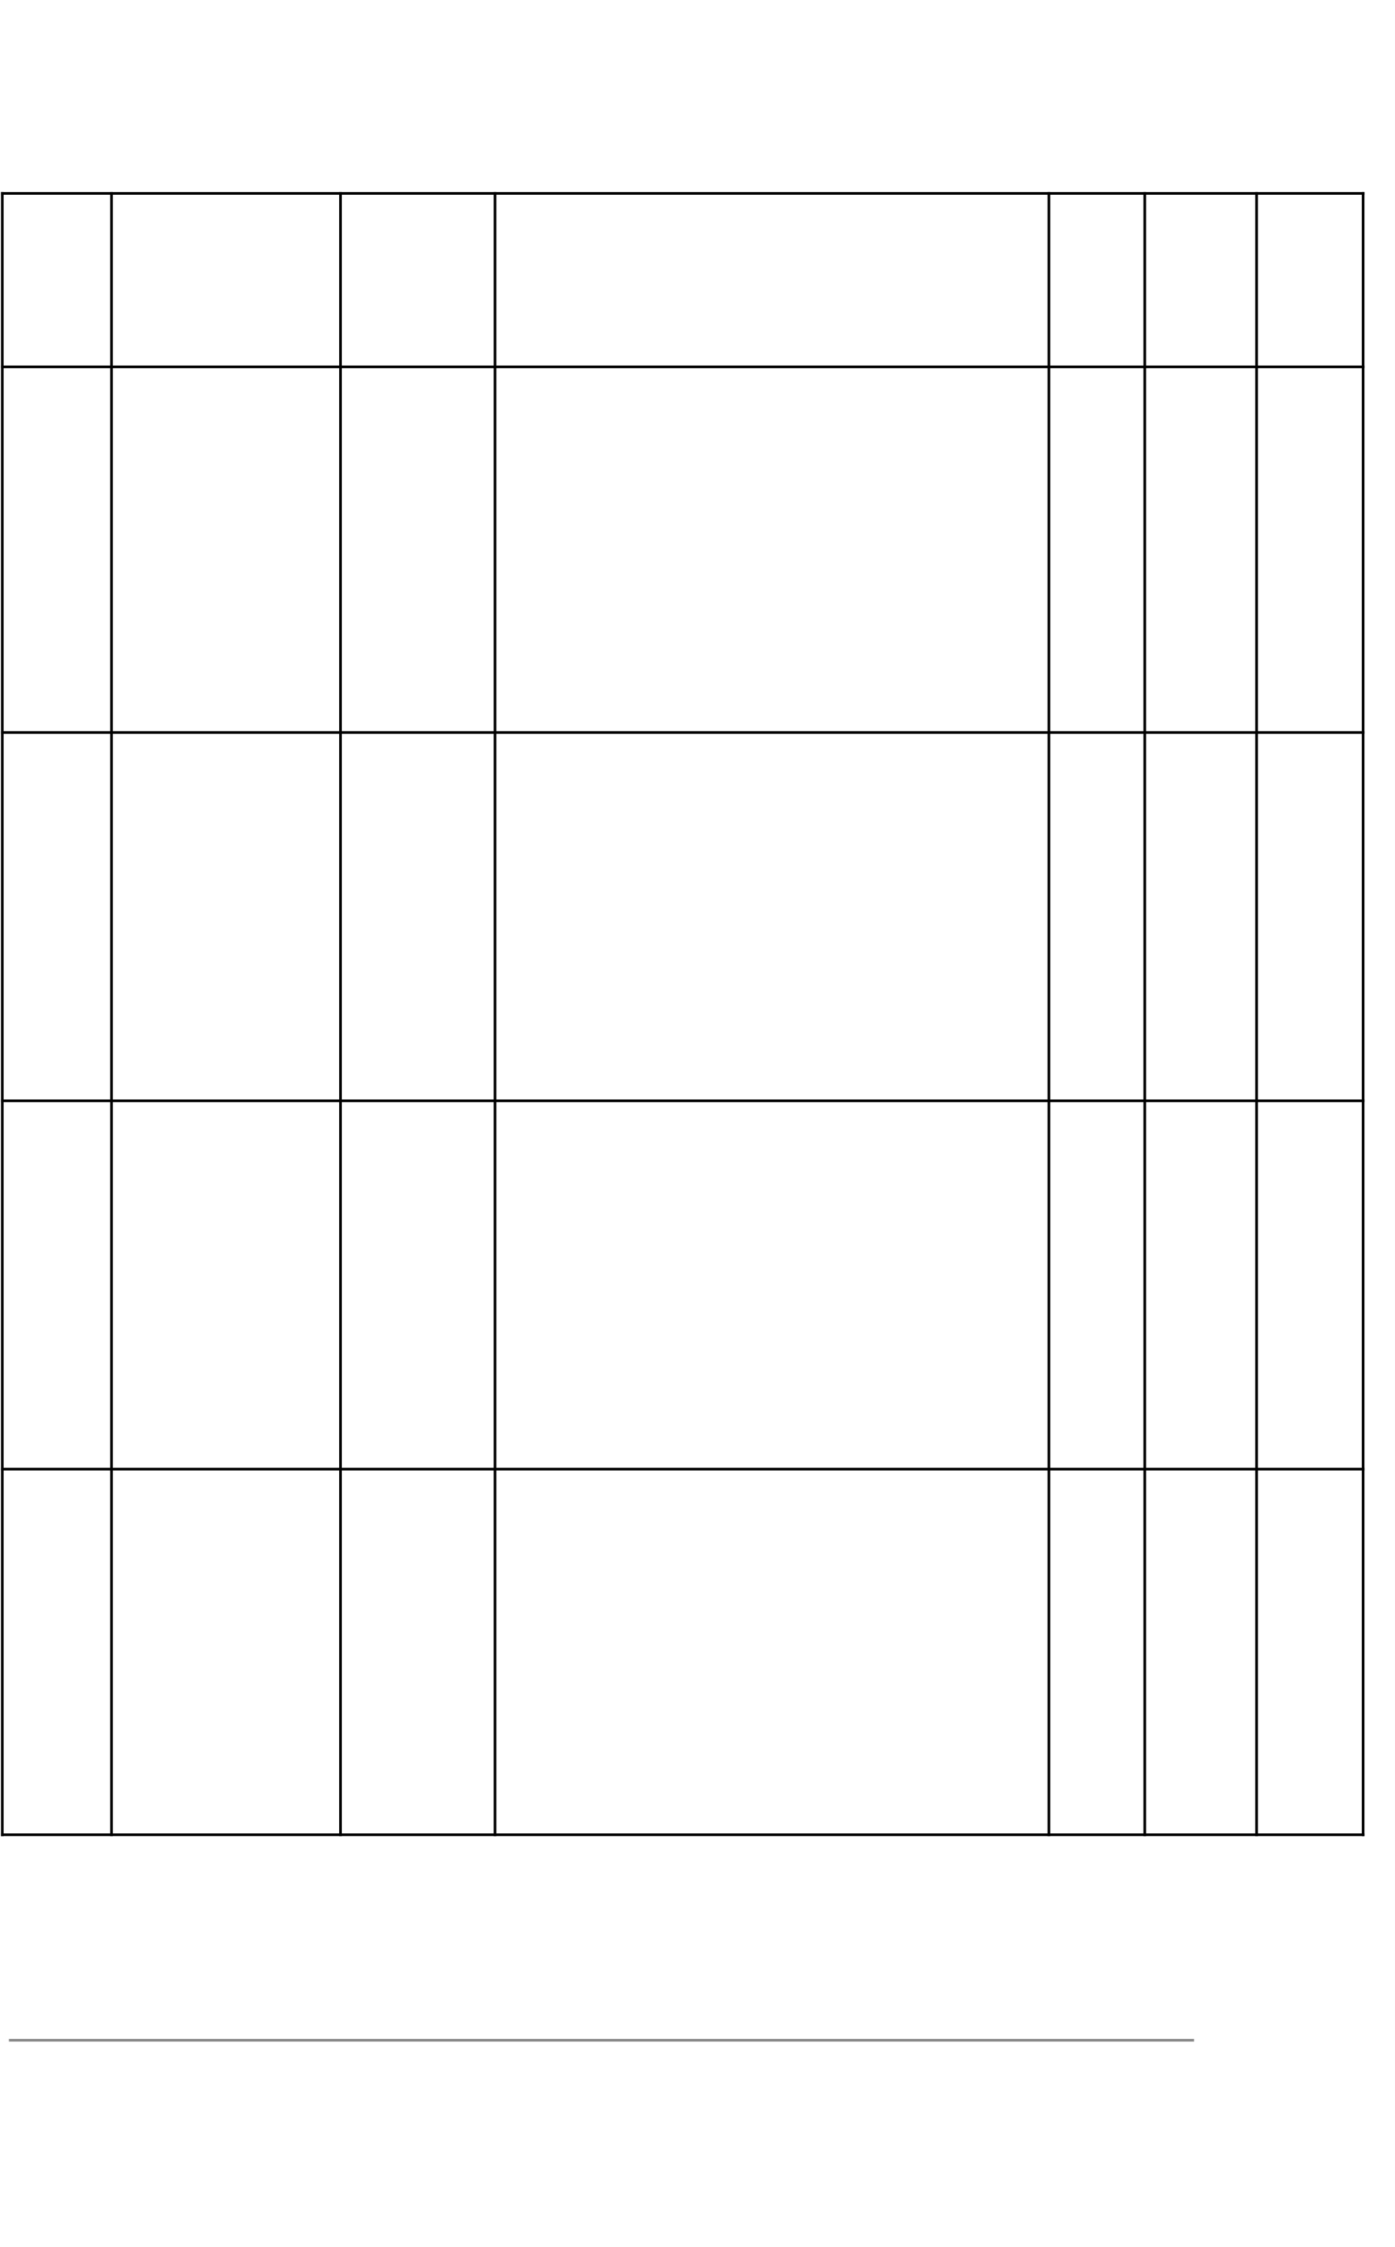
Sprin t-3

Sprin t-4
Seller Application

Admin Management

Order Managemen t

Order History & Review
USN-5

USN-6

USN-7

USN-8
As a user, I can apply to become a seller.

As an admin, I can approve or reject seller applications.

As a seller, I can manage and update order status.

As a customer, I can view order history and leave reviews.
2 Mediu m

3 High

3 High

2 Mediu m

Project Tracker, Velocity & Burndown Chart

Sprint Total
 | Story Points | ion | Start Date | Date (Planned) | (as
Sprint-1 | 20 | 6  Days | 1 May  2025 | 23 Nov 2025 | 20
Sprint-2 | 20 | 6 | 3 May | 29 Nov 2025 | 20
 |  | Days | 2025

Durat
Sprint
Sprint End
Story Points Completed on Planned End Date)
Sprint Release Date (Actual)

28 Nov 2025

4 Dec 2025

Sprint-3 | 20 | 6 | 5 May | 5 Dec 2025 | 20 | 10 Dec 2025
 |  | Days | 2025

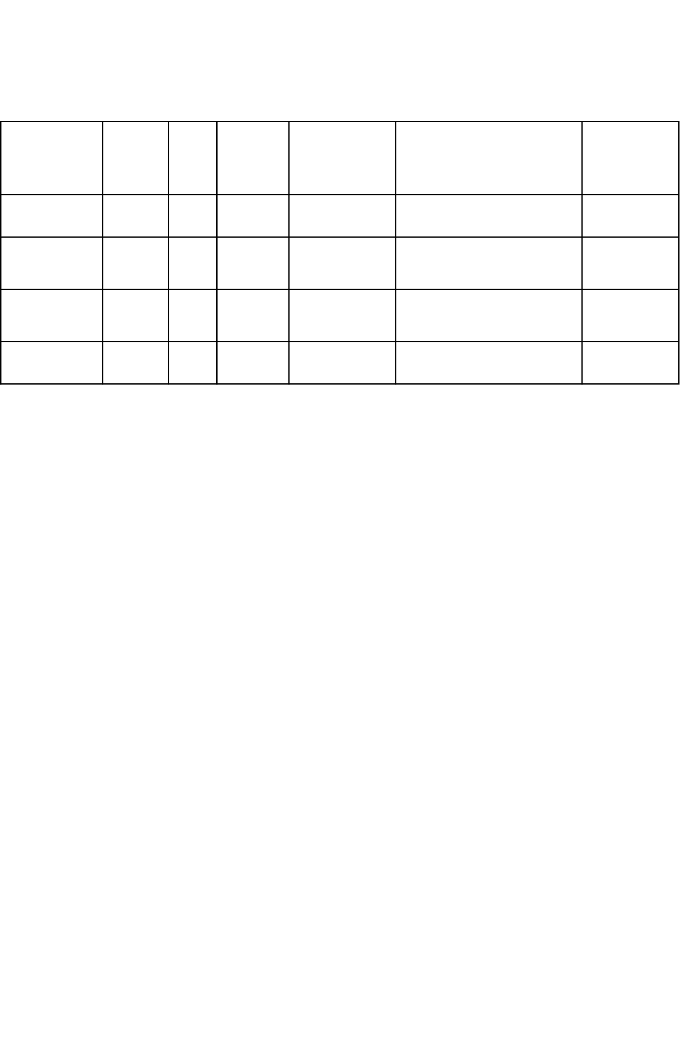
Sprint-4
20 6
Days
7 May
2025
11 Dec 2025 20
16 Dec 2025

